Introduction
The IDKLipse is a plugin for the Eclipse framework which reuses components from the INGENIAS Developmet Kit or (IDK) and the INGENIAS Agent Framework. Therefore, this manual focuses in the essential differences. To gain a complete perspective, please, read as well the IDK manual and the INGENIAS Development Kit development manual. It must be said the IDKlipse uses a subset of the concepts which are applied in the IDK. Concretely, it shows the user only those concepts which are processed by the INGENIAS Agent Framework.
This plugin is in continuous development. It is expected that each improvement made in the IDK is transferred to the IDKlipse. Therefore, it is advisable to check periodically for updates.

Installing IDKlipse
To install this, go to Help menu and then Software updates, and choose the Available Software tab. From that location, press on the Add site button
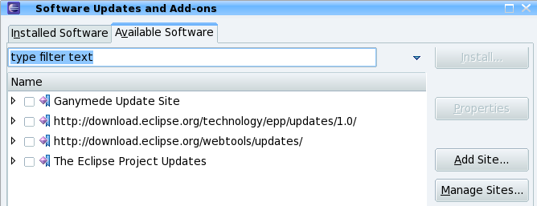
Following, a dialog window will appear. Write there this http://grasia.fdi.ucm.es/idklipse
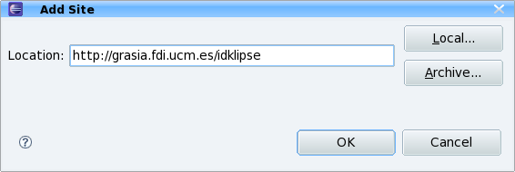
The Available software tab will change, showing the new update site. Select the new entry and then press on the Install button
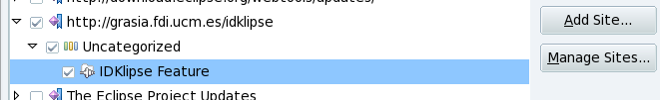
Right after, a new dialog will appear, providing a brief description of the plugin and asking to conclude the install. Please, press Finish.
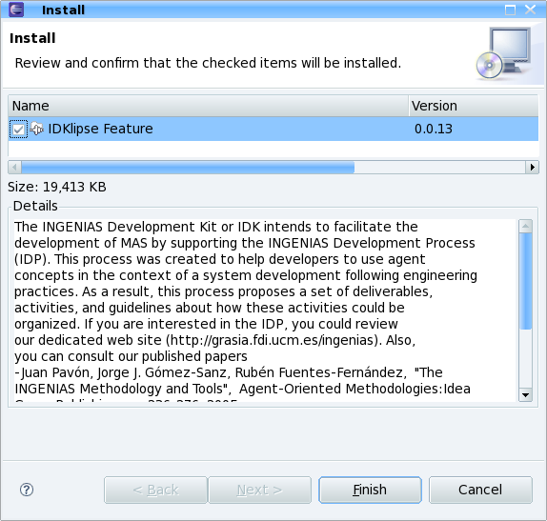
After concluding this part, a dialog will recommend you to restart eclipse
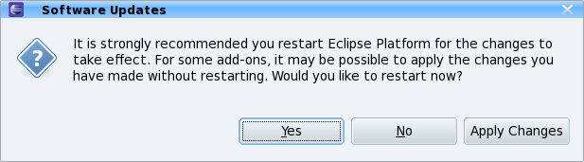
When the eclipse is restarted, the new plugin will be active.

Updating IDKlipse
The IDKlipse can be updated using the Eclipse update features. To request an update, you have to go to Help menu, then Software updates, and choose the Installed Software tab.
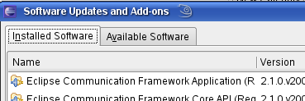
Then, scroll down until you find the IDKlipse entry. Once there, right click and choose update
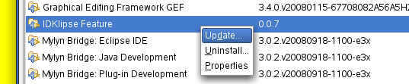
This will open a dialog where you are invited to confirm the update
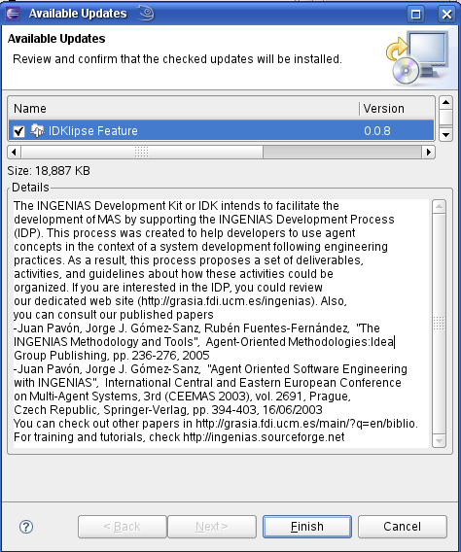

From here, hit finish and the new software will be downloaded. The update will conclude with an eclipse restart.

It is recommended to, later on, hit on Window->reset perspective when you start working within the IDK perspecitve. This will enable any improvements made to the perspective. Nevertheless, any customization made by you will be lost.

Removing IDKlipse
To remove the plugin, it has to be chosen from the Installed software tab. When choosing the plugin and right clicking on it, the uninstall option appears.
The complete remove of the plugin has proven to be difficult. The OSGI framework which manages the plugins does not remove all files as expected in the current version of the IDKlipse. Hence, if troubles occur when installing updates and remove actions do not seem to really clean Eclipse, try reverting the configuration.
Reverting a configuration is enabled by pressing on the revert configuration button in the Installed software tab.
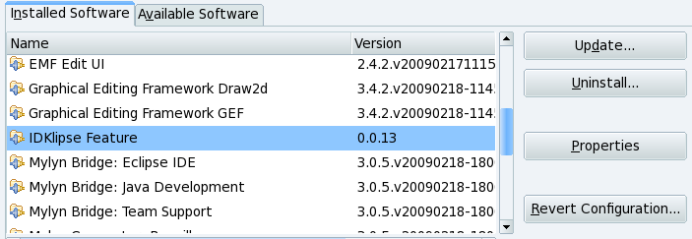
This button will open another dialog where different stored configurations are shown. These configurations are created automatically as new plugins are installed. This way, an eclipse be be rolled back to previous setups. Installed plugins of each configuration are presented on the righ panel. Review each configuration and choose the most recent without the IDKlipse plugin. Once found, hit finish and reboot the Eclipse.
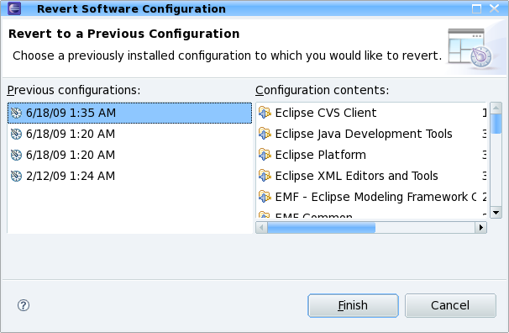
If you were editing a MAS specification, after a revert and a reboot, it is possible you still see the specification open and all INGENIAS widgets properly shown. This is a defect of the revert feature, which does not remove jars from the plugin folder. Hence, Eclipse keeps using it. Nevertheless, opened files can be closed safely and you can use Eclipse as usual.
For removing all binaries, go to your eclipse/plugins folder, and remove all jars starting with IDK (uppercase). To prevent removing the wrong files, the current installed jars are the following:
- plugins/IDKAntRunner_3.0.0.jar
- plugins/IDKPerspective_1.0.2.jar
- plugins/IDKBasicActions_1.0.2.jar
- plugins/IDKProjectView_0.4.0.jar
- plugins/IDKEditor_0.7.0.jar
- plugins/IDKRefreshLibraries_1.0.0.jar
- plugins/IDKNewProjectWizard_0.3.0.jar
- plugins/IDKSearchView_1.0.2.jar
- plugins/IDKObjectView_1.0.3.jar

Creating an IDK project
Go to File and then choose New, and then Project. A dialog window will open showing different options. You can either find the IDK folder, or type idk in the text field to locate the IDKProject entry. Select IDKProject and press Next.
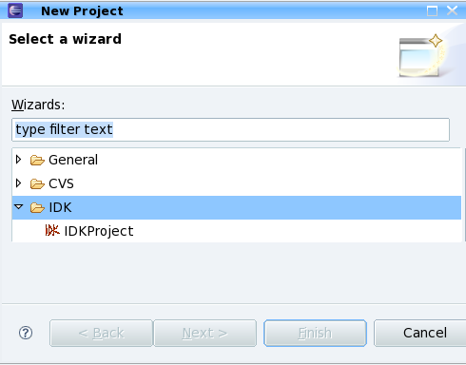
The next dialog permits to customize some options, but in general, it is sufficient to write down a unique project name. Also, the dialog permits to choose an example so as not to start the problem from scratch. You can either choose no template or press on one of the options. To remove the selection, the deselect button can be pressed. After choosing (or not choosing), the finish button will conclude the project instantiation and you will be able to start working.
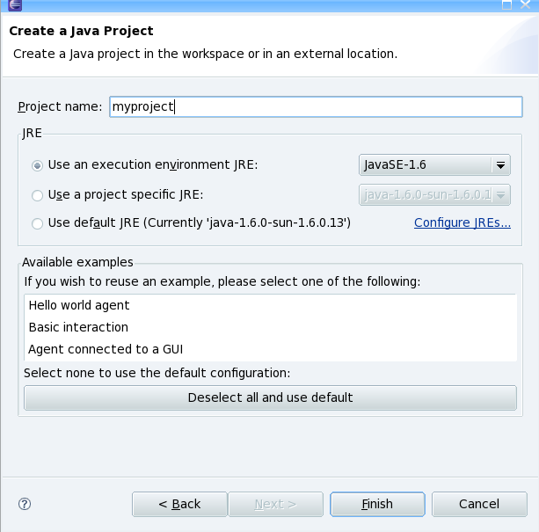
Each template permits to initiate one project with an example that can be used to get used to INGENIAS:
- Template Hello world agent. The template creates a basic agent able to show a dialog window with the message hello world!. It shows how to create a task and make it executable by supplying information to the agent at boot time.
- Template Agent connected to a GUI. In this example, there is an external non-agent software which interacts with the agent. The interaction occurs through the generation of events, which are absorbed by the agent and translated into a task execution. The example illustrates how the non-agent software is declared. It appears as an internal application, though environment application could be used as well. Please, check the INGENIAS Agent Framework development manual for more details about how to declare an application.
- Template Basic interaction. It is a basic query and reply protocol where one agent interacts with at least another. The example shows how the interaction is launched, how to deliver information to the other agents, and how interaction with multiple collaborators is handled.
The details of these basic templates will be introduced in an annex.

Working with IDKlipse
The default working method consists in using the IDK perspective. This perspective is enabled when an IDK project is created. Nevertheless, it can be selected anytime from the Windows → Open Perspective menu of Eclipse.
The IDK perspective is made of the following parts:
- The editor. It allows editing the content of diagrams from the actual specification. It can handle as many as required.
  - Each opened diagram appears in a separated tab
  - Inside each diagram, entities can be created either by clicking on the buttons on the left-side, or right clicking in an opened diagram and choosing the desired entity.
  - Each entity can be edited by double clicking on one of them in an opened diagram.
  - Relationships among entities are created by dragging from one entity to the other as it is done in the original IDK
  - Resize all entities in the current diagram by clicking on the four arrows button
  - Copy and paste entities and relationships from one diagram to the other by selecting them and choosing the copy button from the editor tool bar. Paste the entities and relationships on the current diagram, into another diagram, or in another opened specification. Only allowed entities will be pasted in each diagram. Forbidden entities or relationships will be ignored.
  - Delete entities or relationships in a diagram with the trash bin button in the tool bar or hitting del or back space keys.
- The diagrams view. It shows the names of all diagrams from the current specification. From here, you can:
  - Open a diagram in the editor. Click twice on a diagram to do so.
  - Create a new diagram. Right click over the view in the Project node, or choose a folder in the view. Choose the appropriate diagram type in the popup menu and then write down a name for the diagram when requested.
  - Create a new package. Right click over the view in the Project node, or choose a folder in the view. Choose add package and then type the name of the package.
  - Remove a diagram or a package. Select the diagram or the package in the view, right click over it, and then choose remove package/model. Removing a package will result in the removal of all packages and diagrams beneath it. When removing a package or a diagram, the relationships within them are removed, but the entities are not.
  - Rename a package or a diagram. Select the diagram or the package in the view, right click over it, and then choose rename. Afterwards, type a name in the dialog.
  - Modify the properties of a diagram. Select the diagram or the package in the view, right click over it, and then choose edit properties. This will permit to include a textual description of the diagram as well as modifying the name of the diagram.
- The entities view. It shows all entities created so far in the current specification. From here, you can:
  - Browse the different created entities. Unfold the different entries to review all of them.
  - Select one and add it to the current diagram. It is equivalent to a copy and paste. To do so, right click on the entity and choose add to current diagram.
  - Search occurrences of the entity across different diagrams. To search, right click on the entity and choose search occurrences. Results of the search will appear in the search view.
  - Edit the properties of an entity. To do so, right click on the entity and choose edit properties.
- The run view. It enumerates the different execution options for the current specification. This view is explained in more detail in the next section.
- IDK tool bar. It contains different action buttons to generate code, upload changes from tasks to the specification, upload API changes from applications to the specification,and produce HTML documentation. These buttons are explained in more detail in the next section.
- Search view. When a search is requested from the user, it shows links with the name of diagrams with occurrences of the chosen entity.
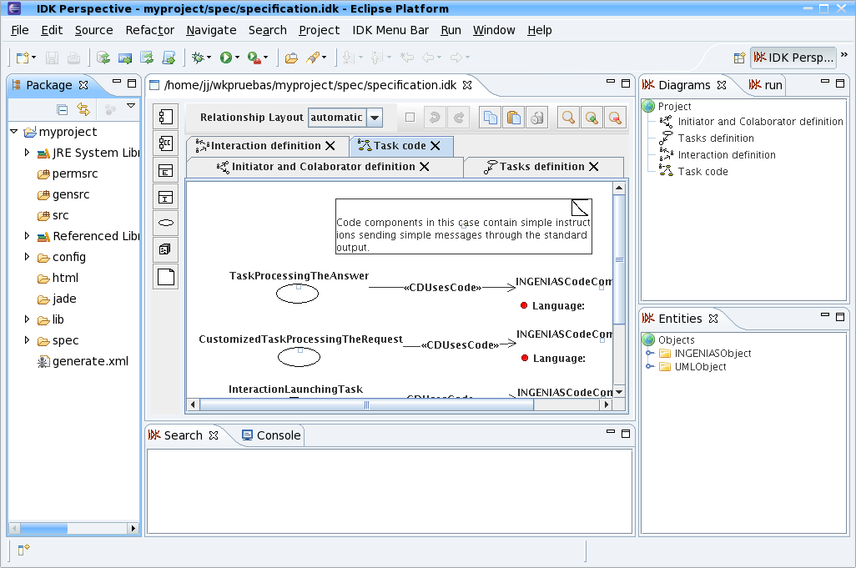
An IDK project is, in fact, a Java Project whose perspective has been customized.

The operations available from here are the same to the conventional IDK. Hence, to create a project, you click on the IDK view, right click, and choose the kind of diagram.
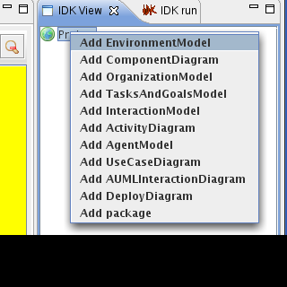

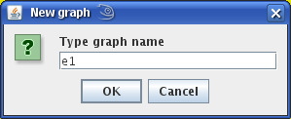

Developing a MAS
An IDK project has the following elements:
- Folder gensrc. This folder contains code automatically generated from the specification. All files stored in this folder can be regenerated if deleted, and each time a code generation action occurs, they are likely to be overwritten
- Folder permsrc . This folder contains files which are generated automatically but never overwritten. If you delete one of the files, and start a code generation task, then this file will be created again.
- Folder src. Files produced by the user, generally utilities and additional software, are stored here. This folder is completely managed by the user.
- Folder spec. It contains the different specifications used in this project. The first specification is called by default specification.xml. There can be as many as desired.
- Folder html. It is the default output folder for the HTML documentation activity.
A development can start from scratch, with an empty specification, or from a template. If a template is chosen, there is a non empty specification which is executable.
If the specification is empty, it is expected from the user to follow INGENIAS methodology and define a MAS. For instructions about how to do this, we refer to the INGENIAS Development Kit manual, the INGENIAS Agent Framework development manual.
When the specification has enough information, it is time to start generating code. Code is generated in three steps:
- Make sure the specification you want to generate code from is opened and active (selected).
- Hit the IAF Generate Code button or select IAF Generate code from the IDK menu.
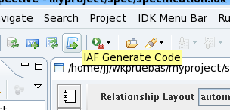 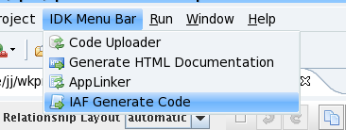
- Watch the console and look for error messages. If none is produced, then the code has been generated successfully. In case of errors, the error message tells what has to be modified in order to fix it.
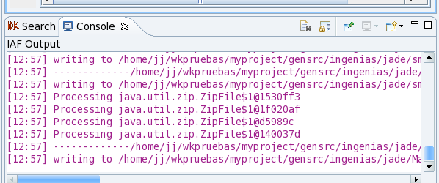
Once generated, you can inspect the left panel where different java packages are presented. You will find new java files which realize the elements from the specification.
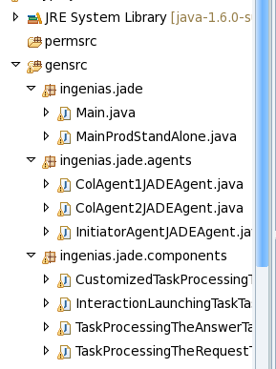
Now, you can move to the run view and evaluate the different execution alternatives. These alternatives require that one element from the current project is selected in the Eclipse. As an example, if nothing appears in this view, or if the name of the project does not correspond to the one you are working on now, go to the Eclipse package explorer and select the folder corresponding to the current menu.
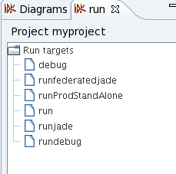

A development with idklipse usually follows this set of actions:
- Create an specification with the editor, perhaps starting from one of the templates
- Generate code
- Select the IDK run perspective and choose either
  - Launching the appropriate jade platform. Then choosing the target containing the agents and launching it as well
  - Launching a prod stand alone target. Such targets have a built in jade container. However, if there is already one available jade container attached to the socket defined in the configuration (default if none), that container will be reused.
- Verify the behavior is the expected
- When there are changes to be made
  - change the corresponding tasks. Changes should be limited to the region delimited by start_node/end_node.
  - Modify the API of the applications. Recognised changes affect only the
  - Modify the initialization/shutdown of the applications
Each of them

Troubleshooting
- The icons do not appear in the tabs
  - Make sure the icons folder or images folder is marked in the fragment.xml/plugin.xml build tab.
- The perspective does not appear
  - Make sure the IDKPerspecitve is selected.Go to Windows-> Open perspective, click on other, and choose the IDK perspective
  - IF still the perspective does not look good, Go to windows → reset perspective
File not found during deployment
- It is possible the file was not included in the plugin. Check out the build tab of the plugin.xml or fragment.xml, and make sure the file is selected in the binary build
General debug info:

Launch eclipse with “eclipse -clean -consolelog”, this will show you all errors triggered.
Send to us the file workspace/.metadata/.log, which will contain exact information of the triggered exception

Problem: When installiing the plugin, it is said there are missing jar files or that there is no plugin repository

Solution: during the generation, you have to delete previously content.xml and artifacts.xml from the IDKLipseUpdateSite folder. If still, there are similar messages, try deleting all entries from your the copy of the eclipse installed on the user's computer
- Remove and reinstall eclipse. This will clean eclipse/p2 folder, which contains all profiles about installed plugins
- Go to the Update software option under the help menu. Go to the installed software tab and click on revert. Choose a configuration which does not contain IDKlipse and accept to revert to that configuration. This will trigger a restart of the eclipse without IDKLipse. Then, you can try to install it again.

Problem: The update site is not showing new versions though there should be one available
Solution:
First, do invoke a refresh of the site with the button. If that does not work, do the following:
- Go to your eclipse install folder
- find the configuration folder
- remove the folder org.eclipse.update
- remove the folder org.eclipse.osgi

